
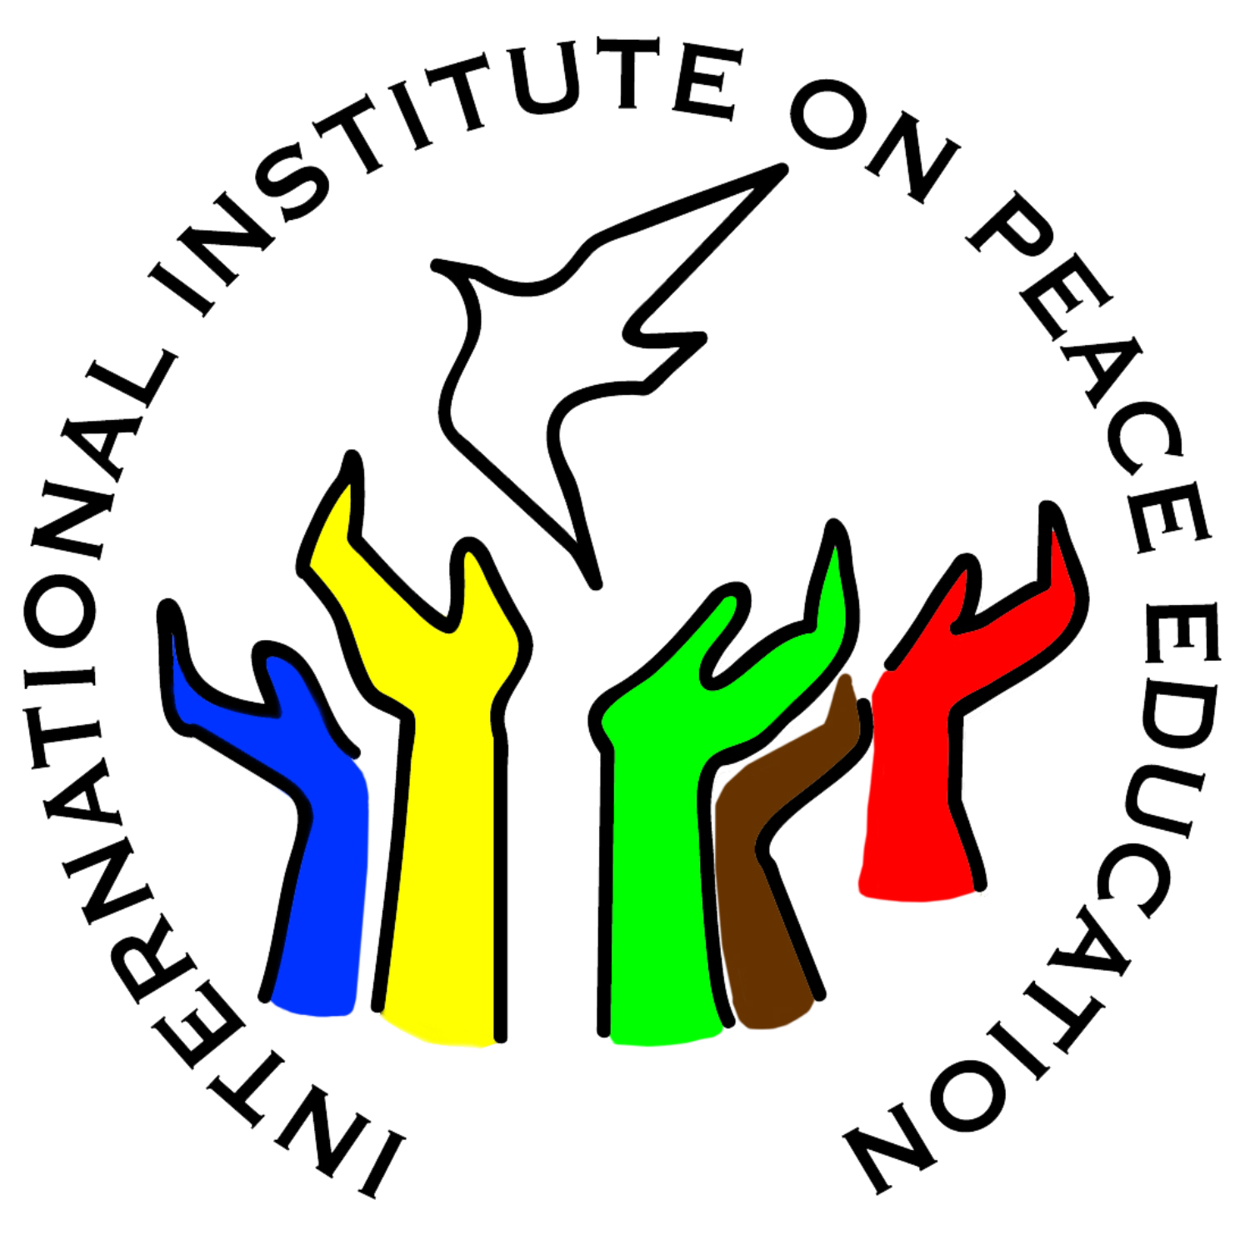

Donate to support the International Institute on Peace Education (IIPE)
and/or Global Campaign for Peace Education (GCPE)

The most effective way to support a sustainable future of the IIPE & GCPE is to become a recurring donor! By donating just a few dollars a month (less than the price of a cappuccino!), you can help us to plan a stable financial future. To become a recurring donor, please use the links to our online donation forms below. Set-up is quick, easy, and automated.

The IIPE and GCPE are independent and complementary projects that are jointly administered in an effort to keep overhead low. Both projects are fiscally sponsored by the National Peace Academy, a U.S. 501c3 non-profit (EIN 27-2285227). All donations are tax deductible to the extent allowable by law.

Questions? Please contact Tony Jenkins - tel: +1-202-556-1075 email: jenkins@i-i-p-e.org.

To donate by credit card (or set-up a recurring donation) please use our online forms:
www.peace-ed-campaign.org/donate
www.i-i-p-e.org/donate

To donate by check, please make checks payable to:
“National Peace Academy”
(*”National Peace Academy” must be included on the check “to” line! We also recommend including “IIPE/GCPE” in the memo line.)

Mail your check – with a copy of this form – to:
National Peace Academy
PO Box 21155
South Euclid, OH 44121
I (we) would like to make a donation in the amount of $ to support the International Institute on Peace Education.  I (we) would like to make a donation in the amount of $ to support the Global Campaign for Peace Education.  Please direct my donation in the amount of $ to wherever it is needed the most.  Please recognize my donation in honor of (a special occasion, in memory of…): . | Name:  Address:  City State Zip  Email Phone  I prefer that my donation remain anonymous.  I give permission to include my name in a public list of donors.

Please include a note or any special instructions:

